**VI. Install a Plugin using WordPress Plugin Search**

1. Before installing the plugins, login in first in your WordPress account. Enter your username and password the click “Log in”.

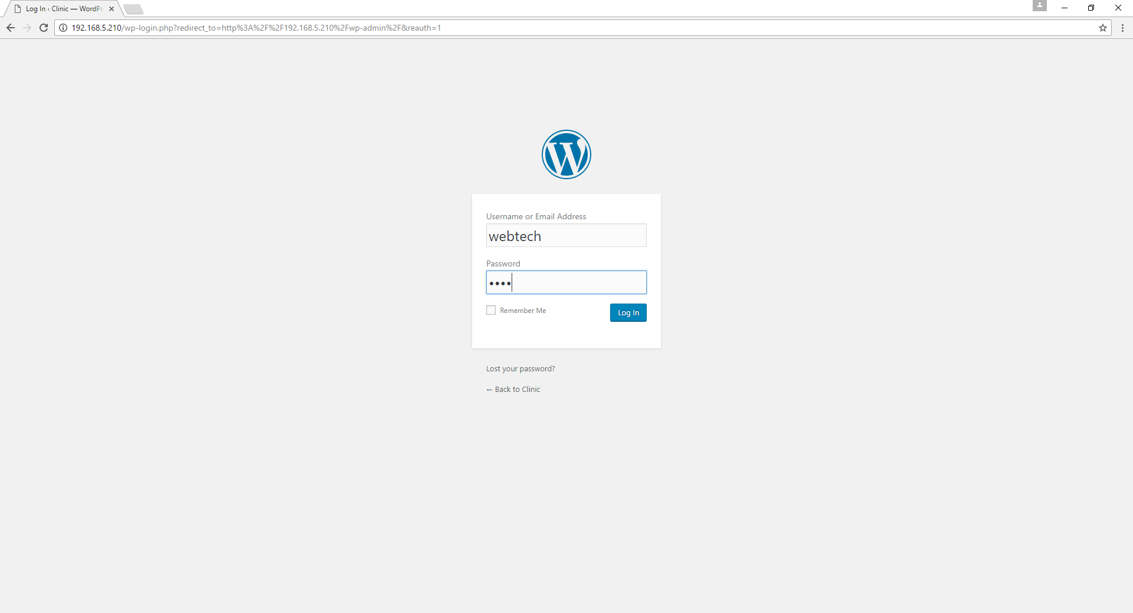

Figure 38: Logging in to your WordPress Account.

1. After logging in your account, it will display the WordPress Dashboard. Click on Plugins and there you will see the list of different plugins that you wish to use in WordPress. You can also search the plugin you wish to use by typing the plugin name in the search box. After typing the plugin name, you will see a bunch of list related to the plugin name. Then, click on “Install Now”.

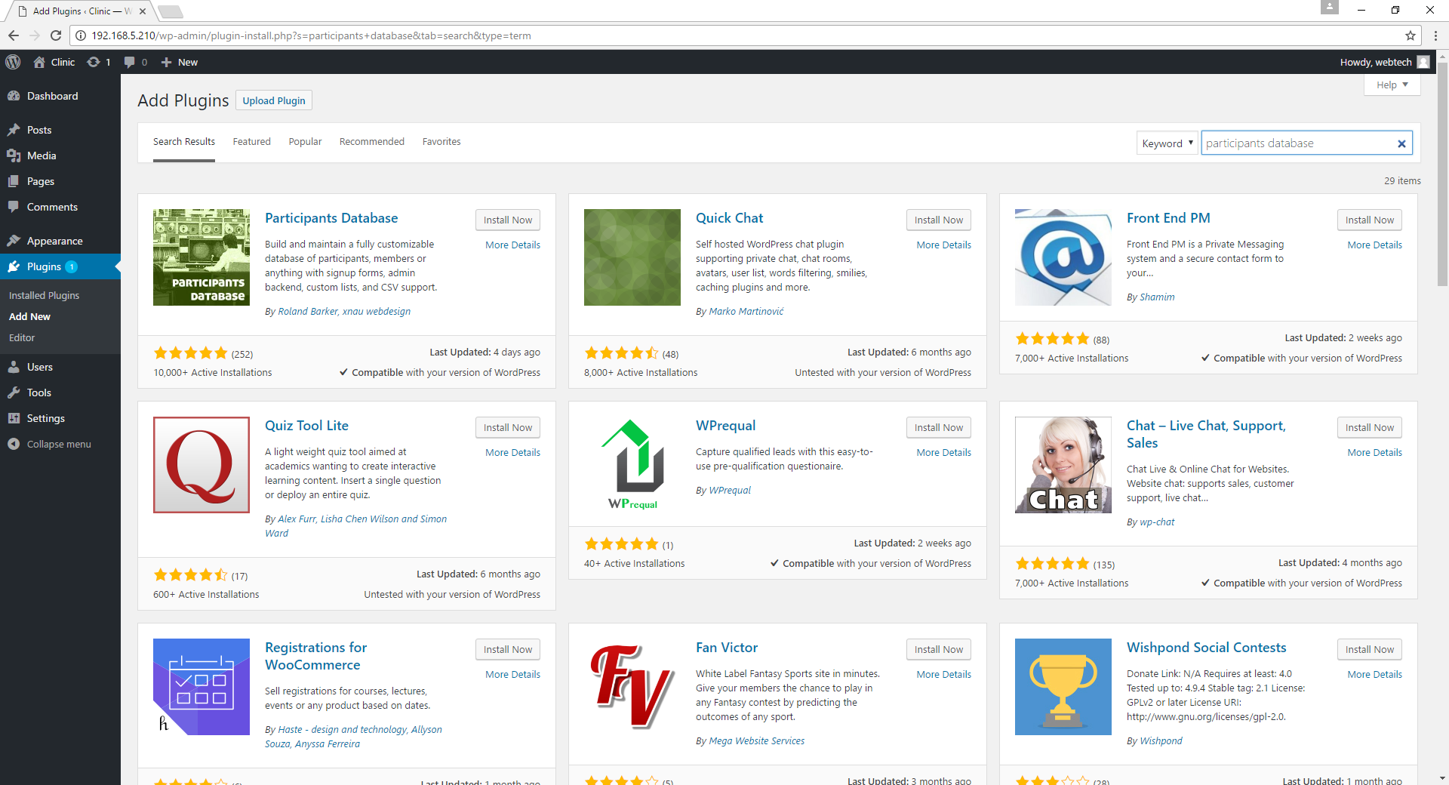

Figure 39: Searching the plugin you wish to use.

The plugin in is now installing.

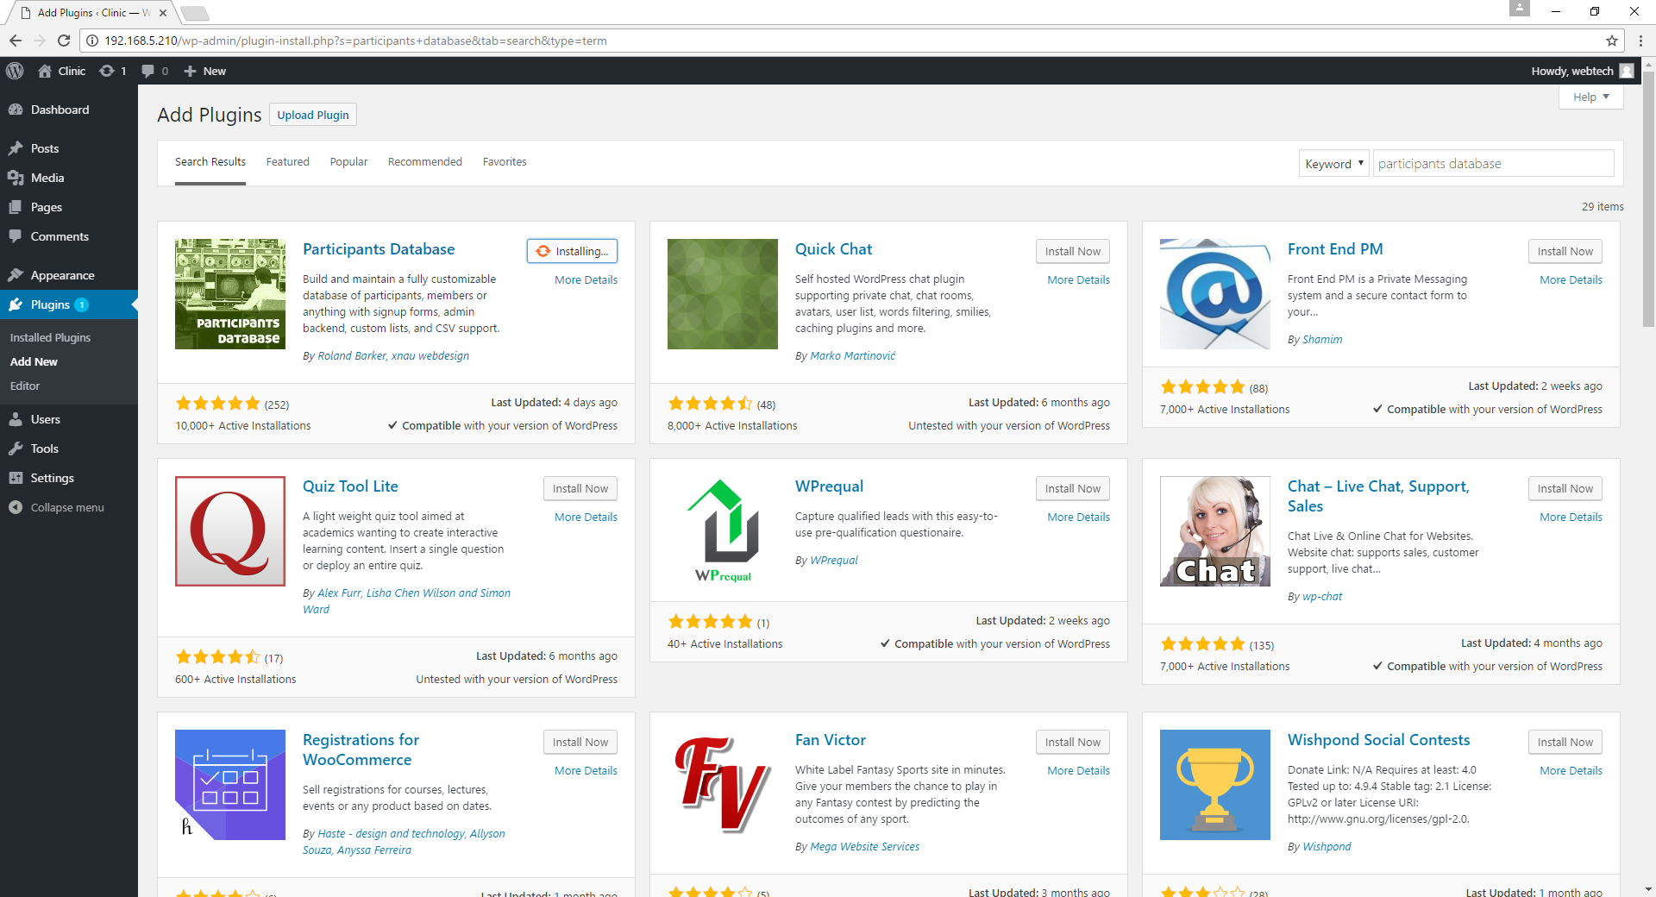

Figure 40: Installing the plugin.

If the plugin is successfully installed, click “Activate” to activate your plugin.

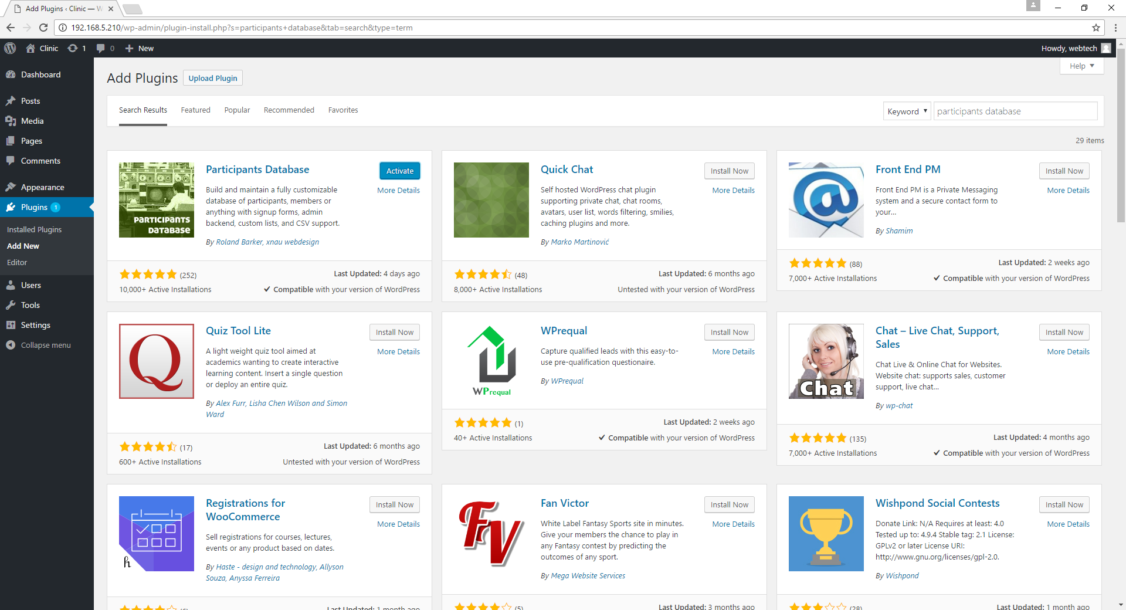

Figure 41: Activating the plugin.

Then it will display in the screen that the installation was successful.

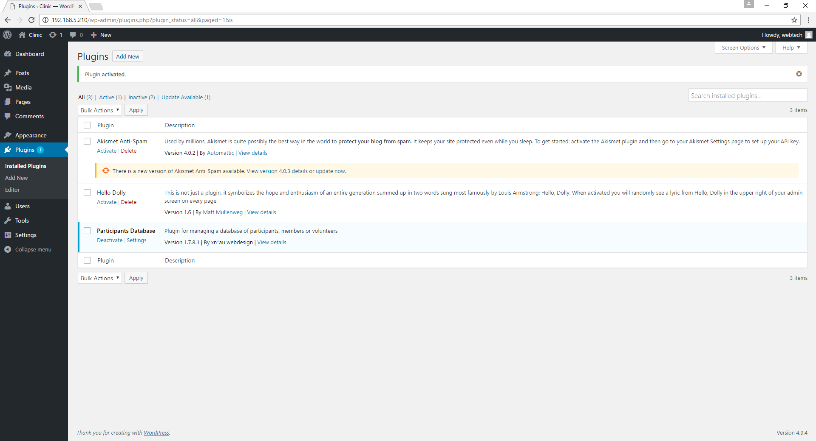

Figure 42: The file is already activated.

1. Repeat step number 2 if you want to add more plugins.

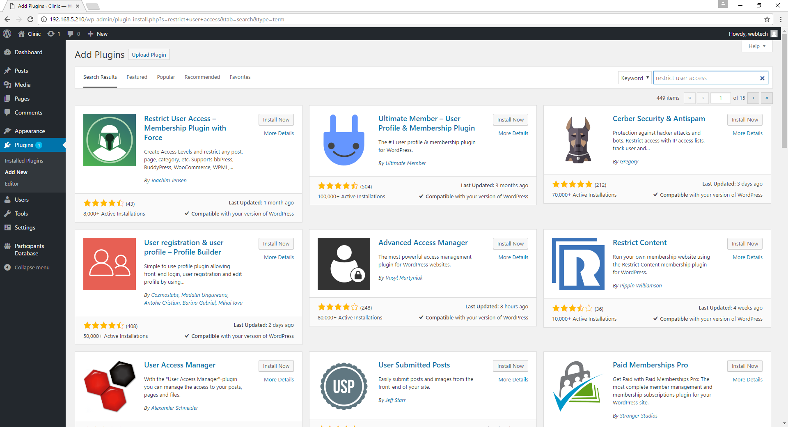

Figure 43: Searching and installing for “restrict user access” plugin.

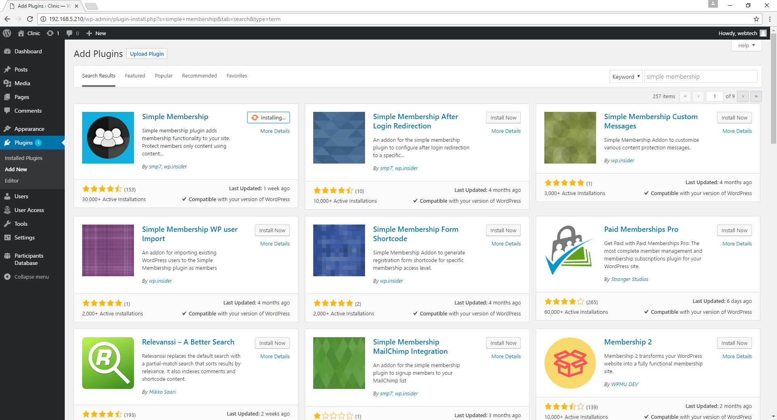

Figure 44: Searching and installing for “simple membership” plugin.

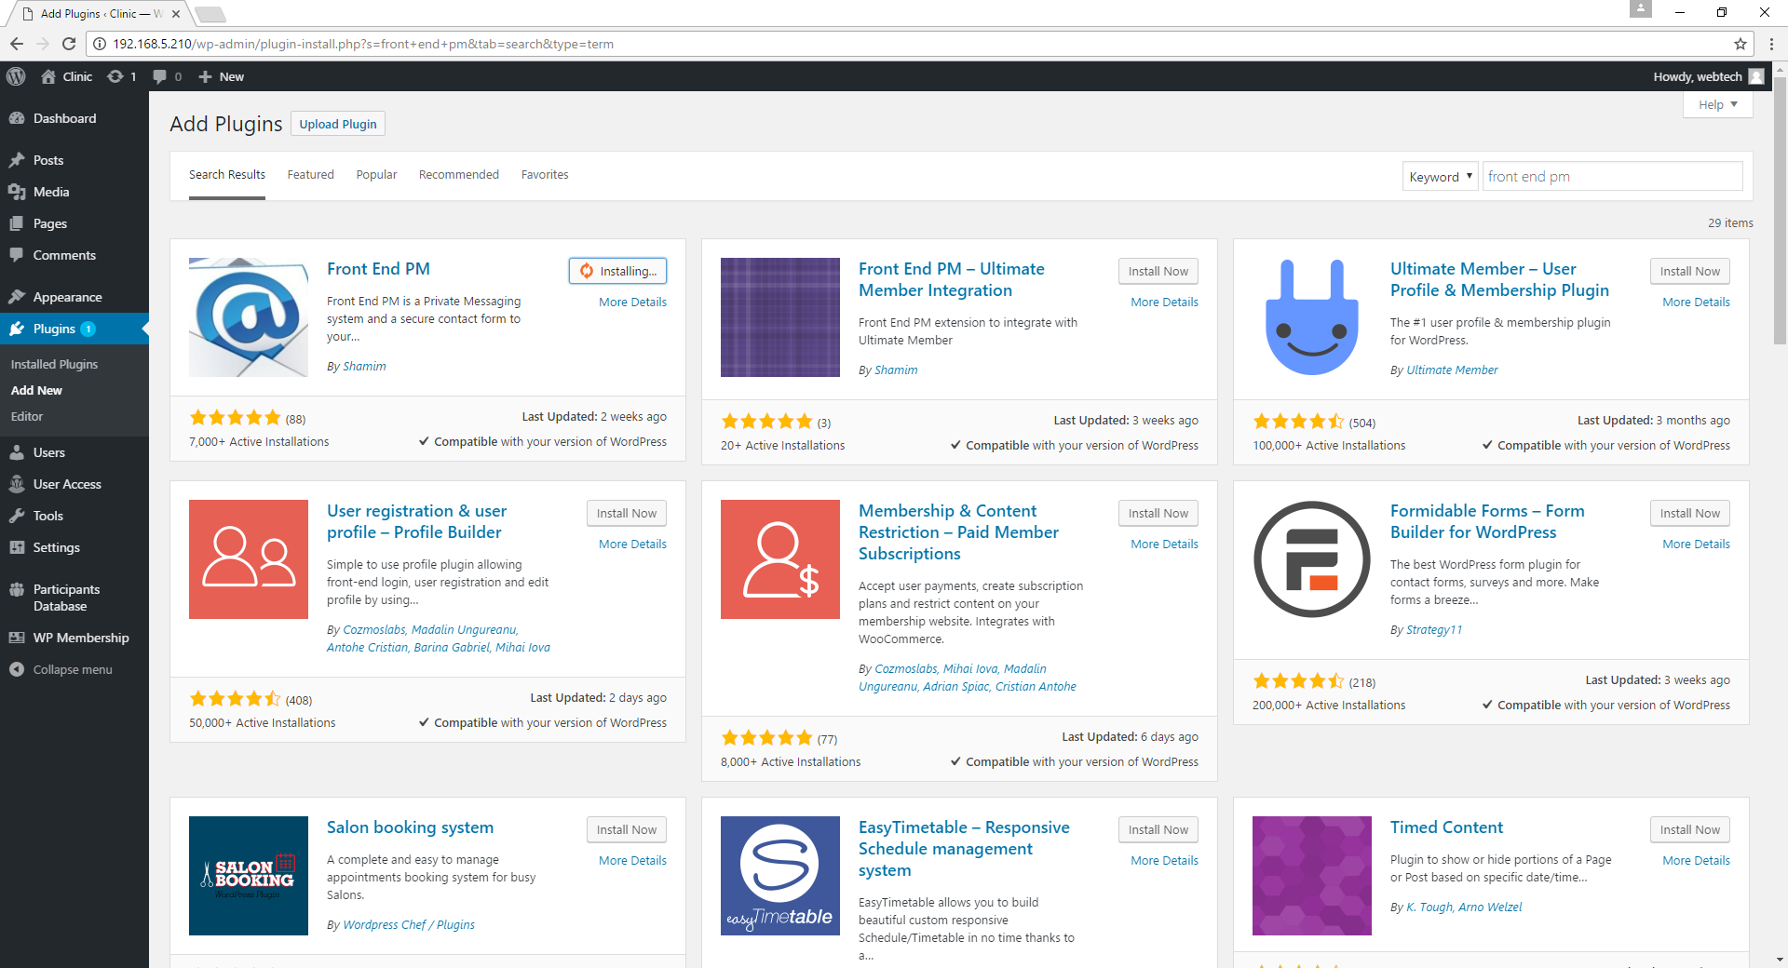

Figure 45: Searching and installing for “front end pm” plugin.

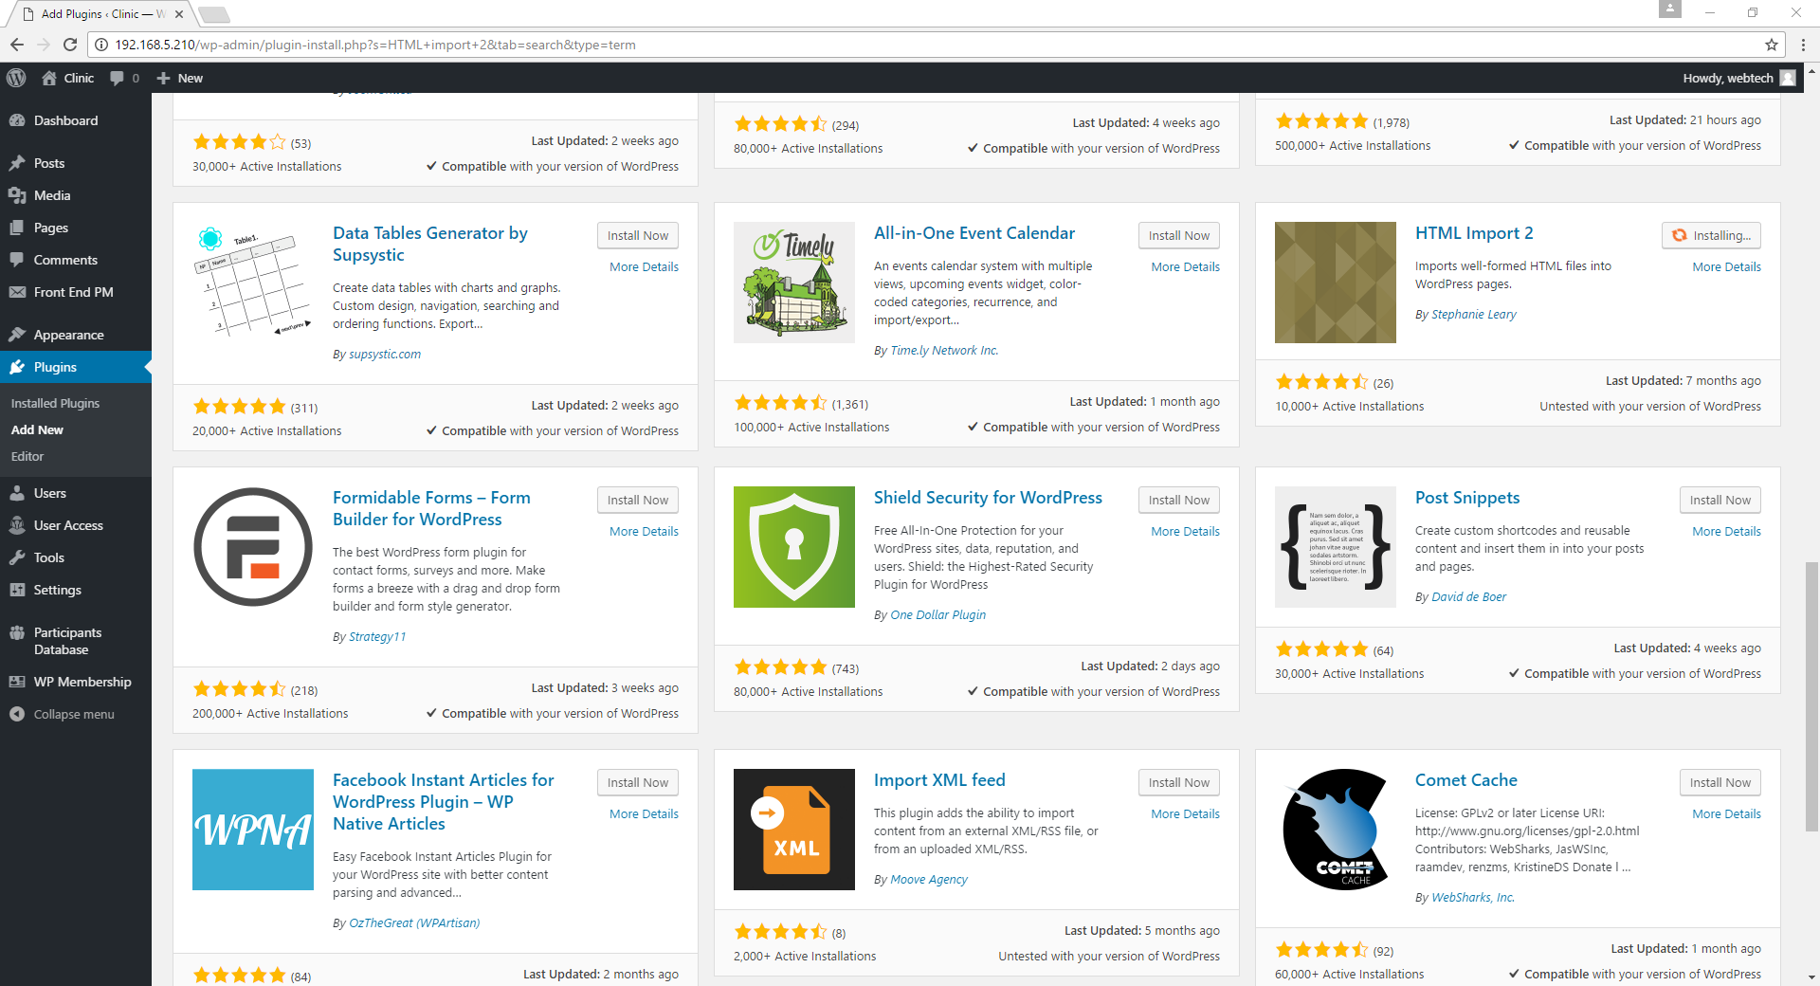

Figure 46: Searching and installing for “HTML import 2” plugin.

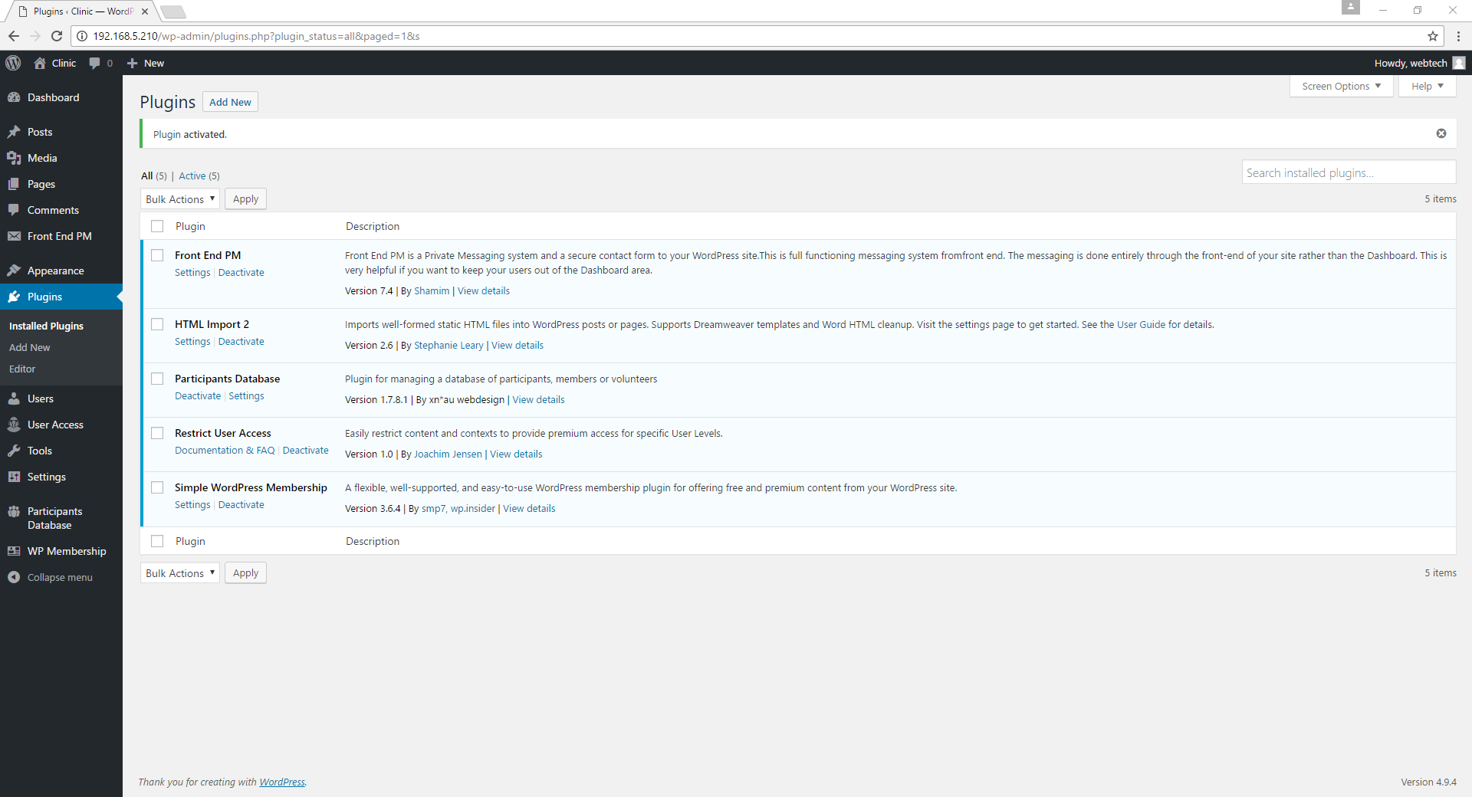

Figure 47: All the plugins that have been activated.

**VII. Creating users in Wordpress**

1. In adding a user in Wordpress, go to Users and click Add New.

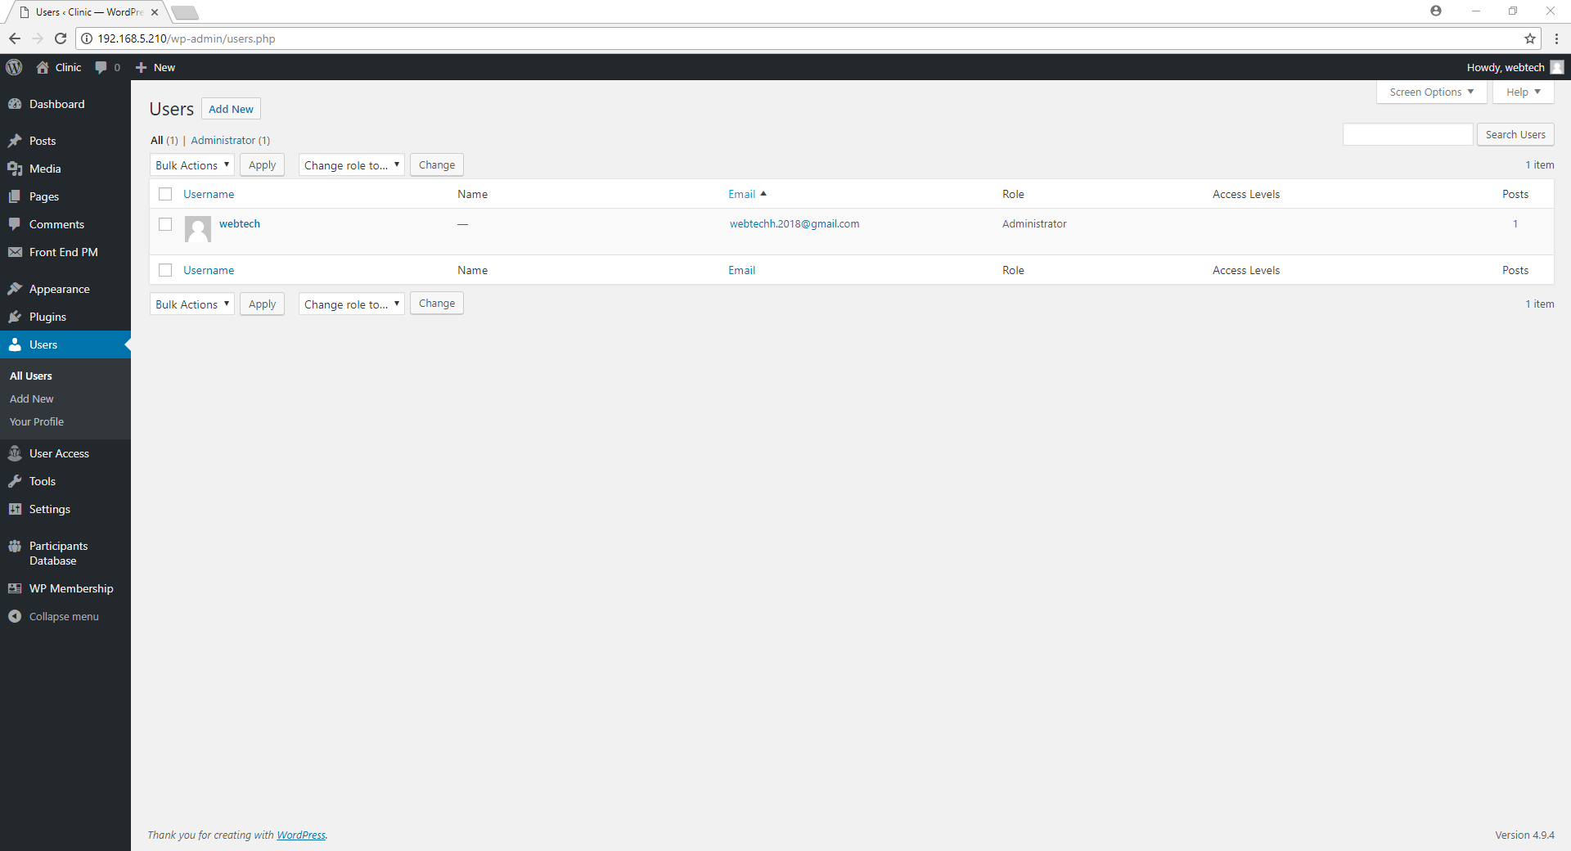

Figure 48: Adding a user.

1. Fill up the following information: Enter the **username, email address, first name, last name, website, and password** of the user then click “Add New User”.

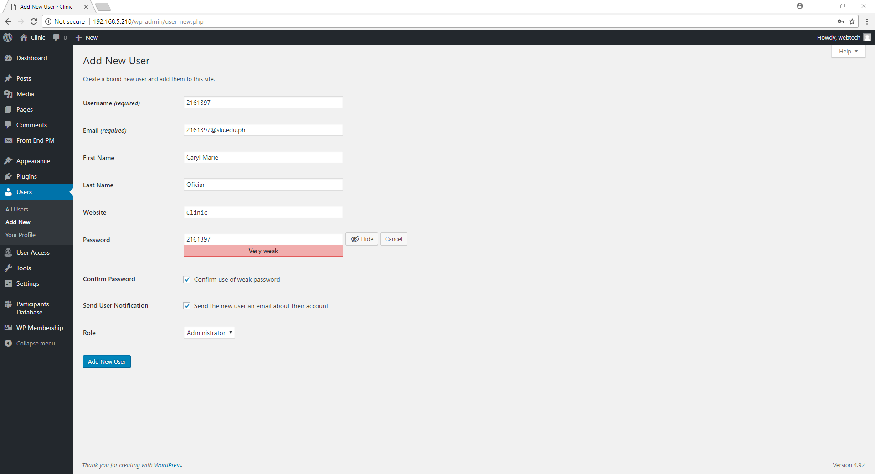

Figure 49.1: Creating and adding 2161397 as a new user.

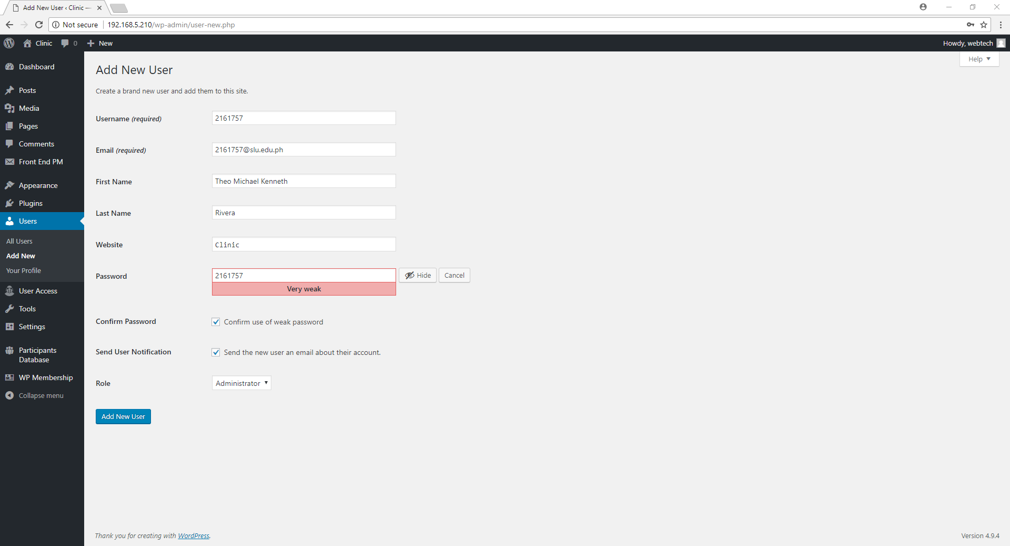

Figure 49.2: Creating and adding 2161757 as a new user.

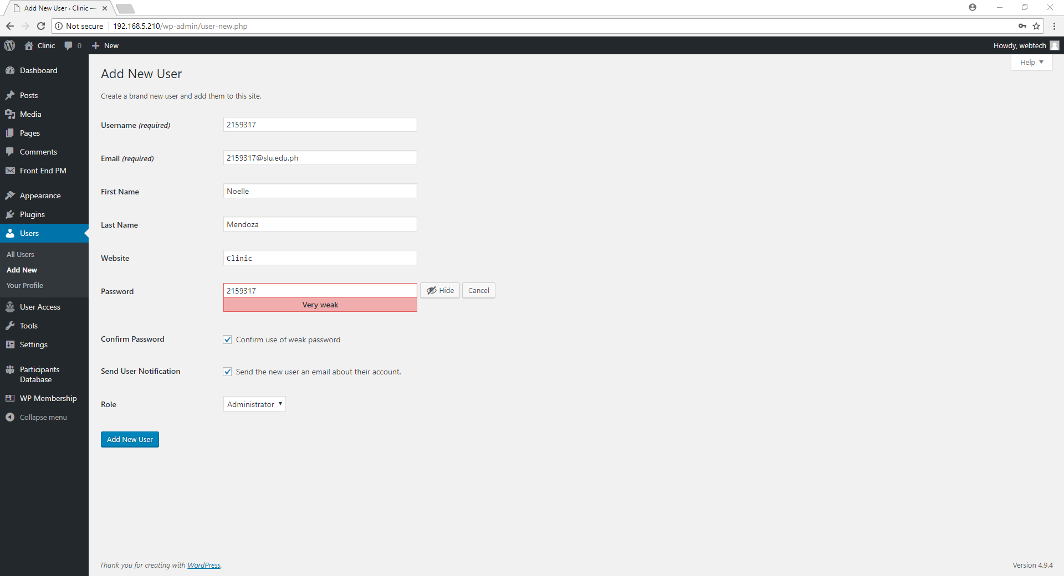

Figure 49.3: Creating and adding 2159317 as a new user.

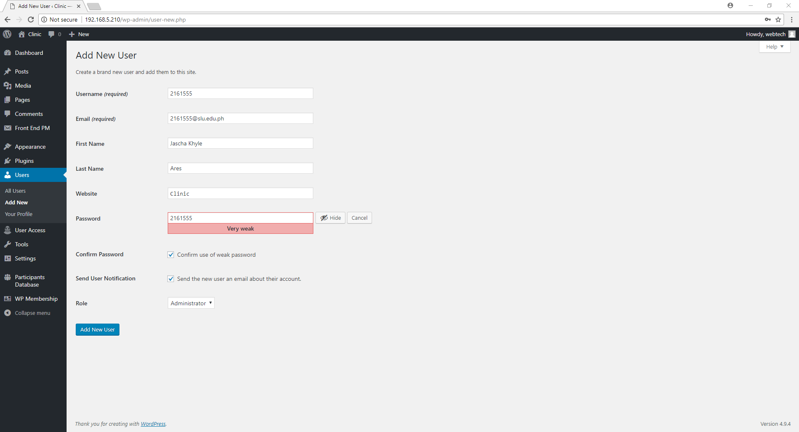

Figure 49.4: Creating and adding 2161555 as a new user.

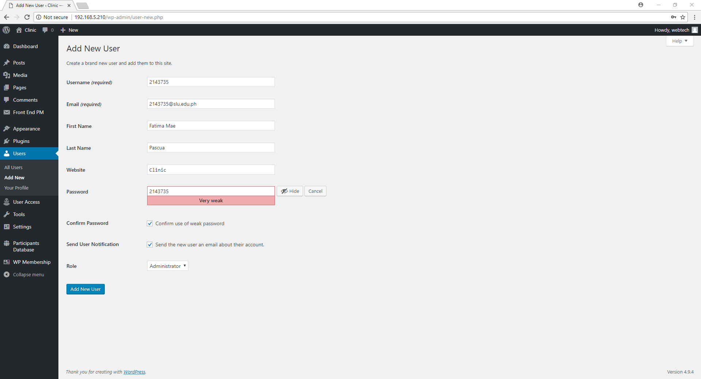

Figure 49.5: Creating and adding 2143735 as a new user.

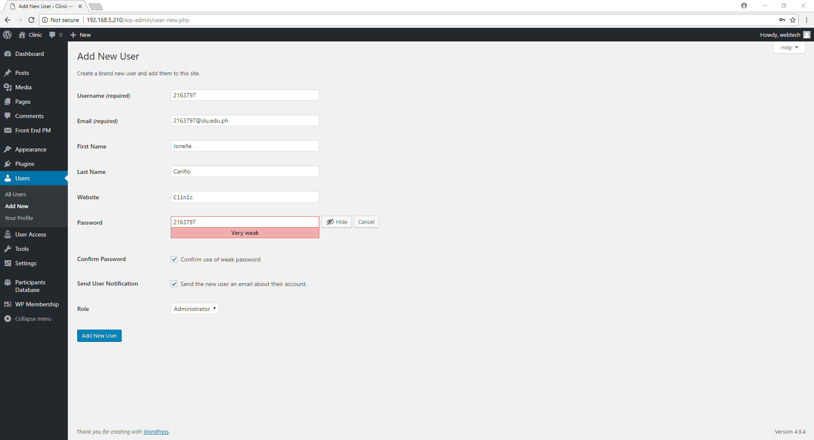

Figure 49.6: Creating and adding 2163797 as a new user.

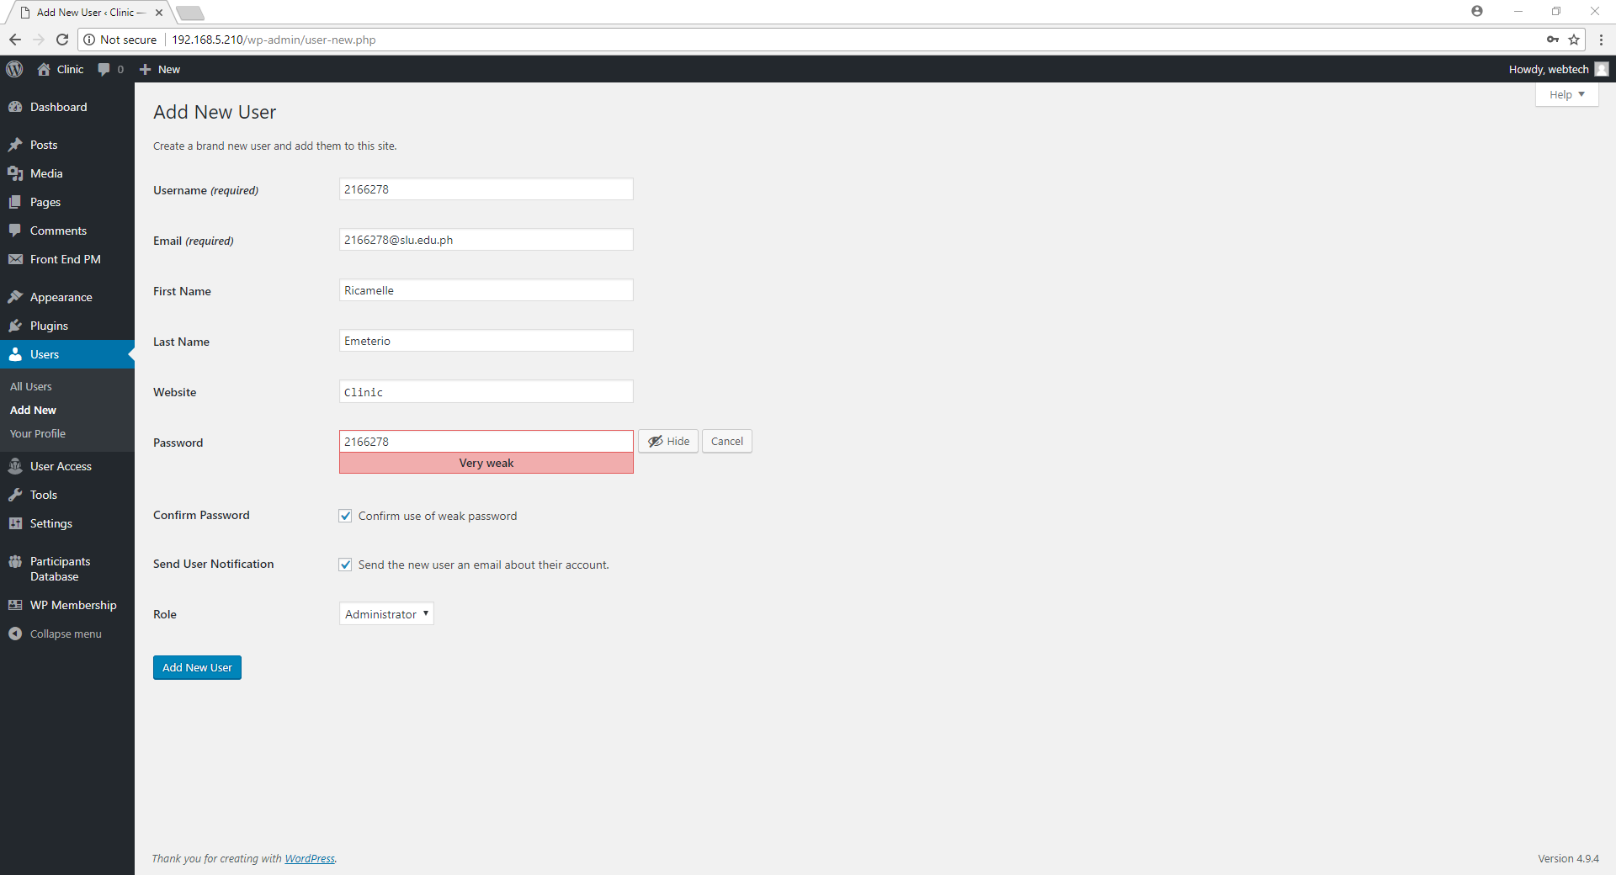

Figure 49.7: Creating and adding 2166278 as a new user.

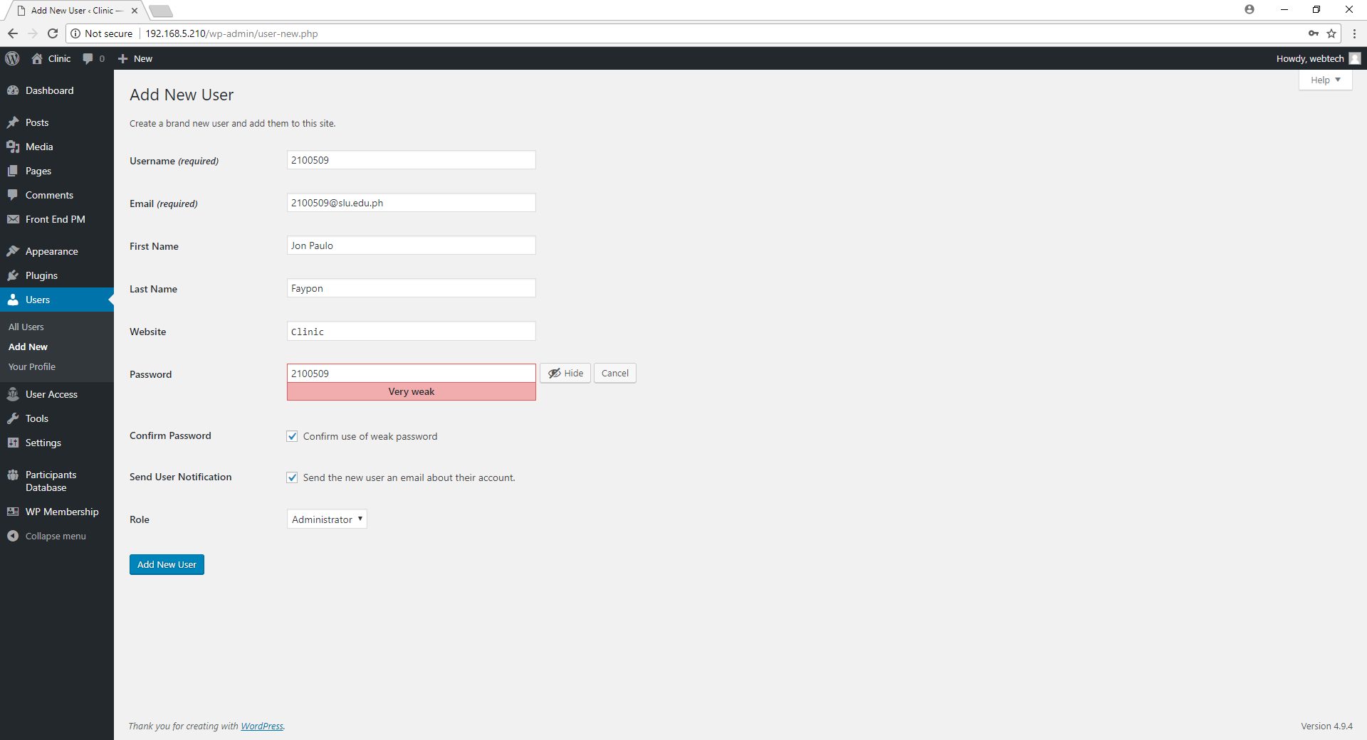

Figure 49.8: Creating and adding 2100509 as a new user.

1. Go to Users and click All users and it will display the list of all users in the Wordpress.

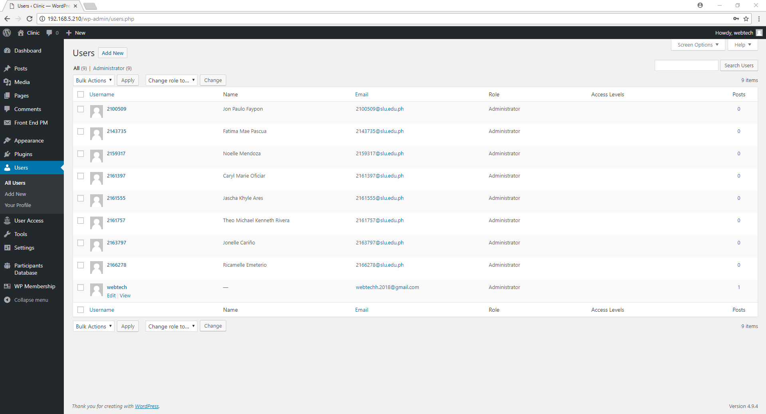

Figure 50: Displaying the list of all users.